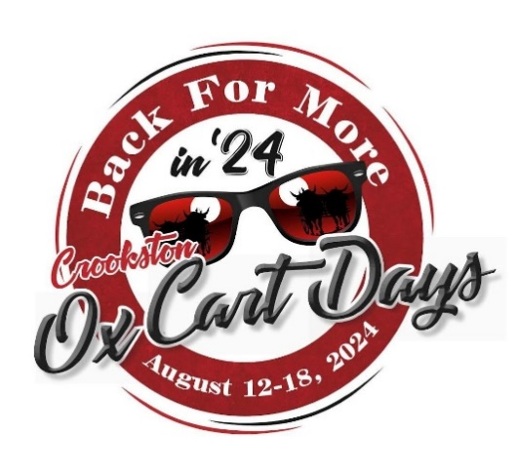

**Parade Entry Form**

**Saturday, August 17, 2024**

**Please complete and return no later than August 9, 2024**

**TYPE OF ENTRY TYPE OF UNIT**

**Non-Profit Agency Car**

$5 **Float**

**Political Walkers**

$20 **Animal**

**Any Individual, Commercial or Business Other**

$20 (up to 2 units) $5 each additional unit

**Float Details**

Float Name

Organization

Contact Person

Phone Email

Address City, State, Zip

# of people participating # of units in entry

Does the unit have music? If yes, what kind?

Yes No Live Recorded

Does the unity have animals? (**MUST** have pooper scoopers)

Yes No If yes, what type?

Is the unity decorated with lights (floats only)?

Yes No

**Float Description**

This information will be used by the announcer and should be detailed and complete. List names of all royalty, band directors, and others included in entry.

**\*Any entries received after the deadline may be placed towards the end of the parade line-up and unfortunately may not be included in the parade script.**

Please make all checks payable to:

**PLEASE NOTE:** There will be **NO** early registration on the parade date. The registration desk will be open from **5:00 pm – 6:30 pm** in front of Rockstar Grooming at 802 North Broadway.

*Your **unit #** will be emailed to you during the week of OxCart Days.

**CANDY CAN NOT BE THROWN FROM MOVING VEHICLES – IT MUST BE HANDED OUT.**

**Crookston Lions Club**

Please return this form and payment to:

**Crookston Lions Club**

**Torchlight Parade**

**PO Box 1**

**Crookston, MN 56716**

**This event is managed & sponsored by the**

**Crookston Lions Club**



Keep up to date with our Facebook page

**www.facebook/oxcartdaysfestival**